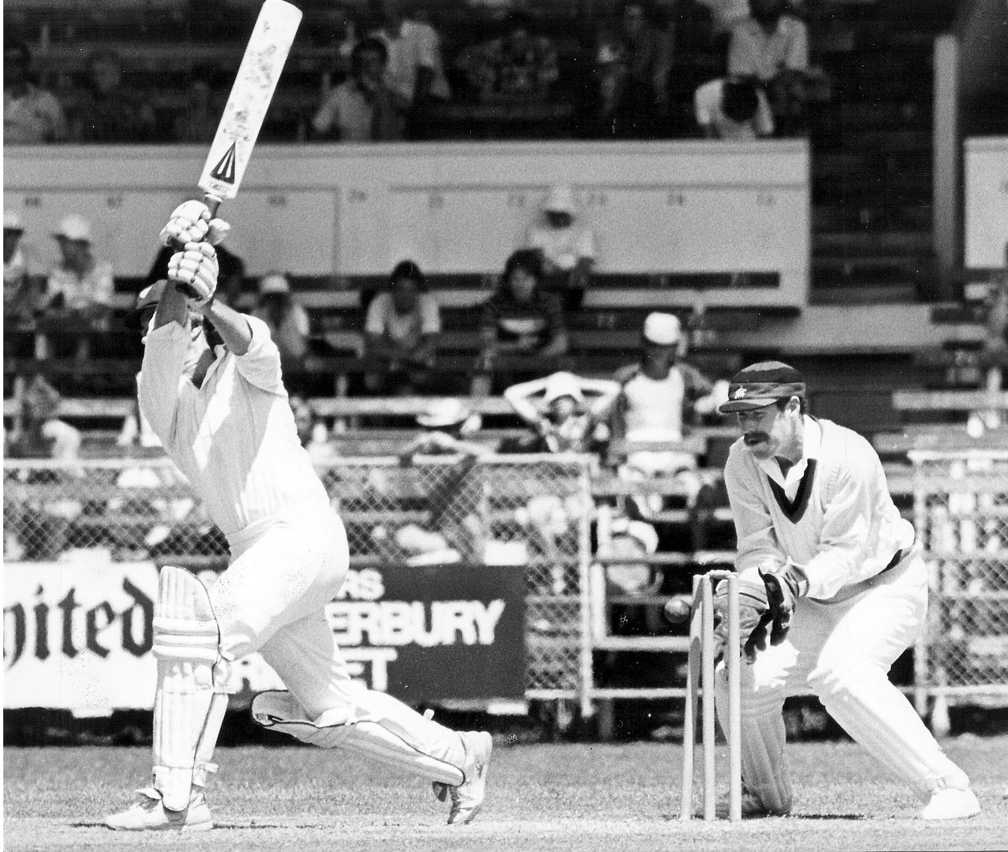

**John Parker bowled by David Stead for 58 Wicket keeper Ash Hart.**

**Lancaster Park 31 December 1983**

**Northern Districts 170 and 104 Canterbury 175 and 103/5. Canterbury won by five wickets**